**Worksheet-1**

**Machine Learning**

**Find –S Algorithm**

Find a maximally specific hypothesis? Sunny,warm,?,? many,?,No,?

How many concepts are possible for this instance space? 16, 36

How many hypotheses can be expressed by the hypothesis language? 256 ,400

How many semantically distinct hypothesis?82, 145

**Question: 1**

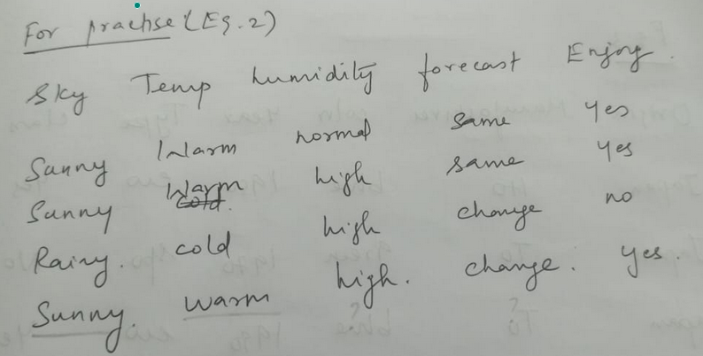

**Question: 2**

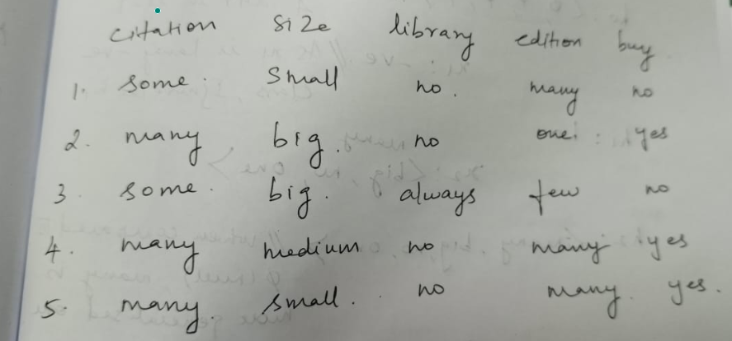

**Candidate Elimination Algorithm**

Find the General and Specific hypothesis for the given dataset

**Question: 3**

**G No hypothesis**

**S Small,?,Circle**

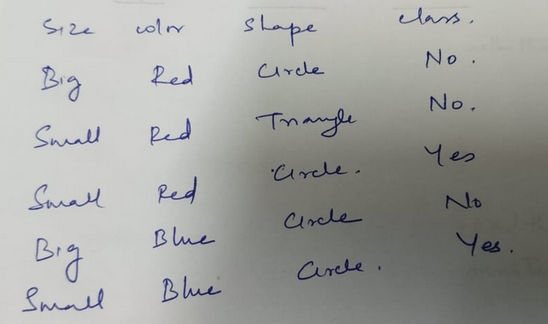

**Question: 4**

**G {Many,????}**

**S{Many,?,NO,??}**

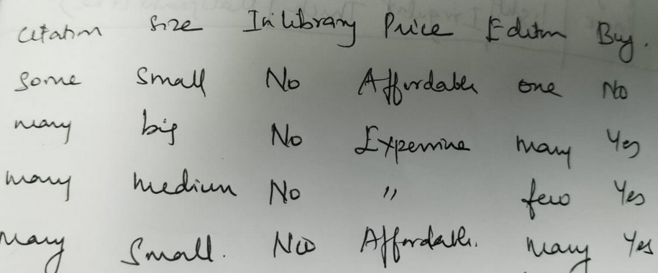

**Question: 5**

**G{??Light??} {????Thick}**

**S {?large,light?thick}**

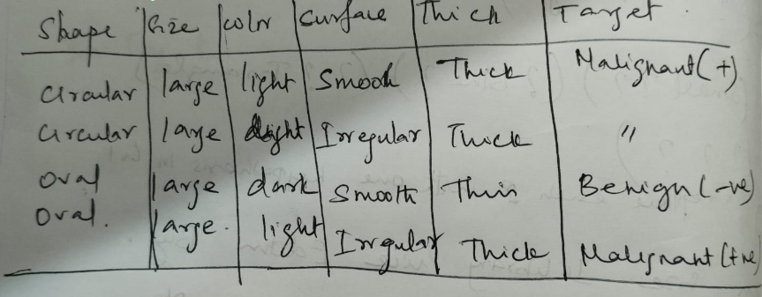

**PAC Learning**

**Question: 6**

Find the hypothesis that is a good approximation of target concept f(x) using PAC learning to classify the given dataset as even and odd numbers. Train the model using the dataset,



And test the model using the dataset



**Question: 7**

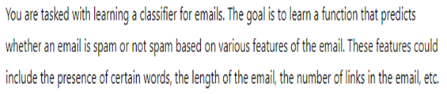Calculate the sample complexity using PAC learning method. Assume the following values,

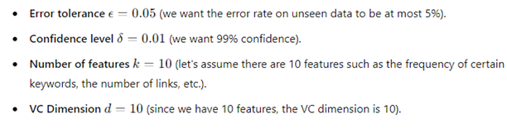

**Linear Regression**

Formulate the line of equation for the following questions and find the following

1. Mean Squared Error(MSE)
2. Mean Absolute Error (MAE)
3. Root Mean Squared Error(RMSE)
4. (iv) Standard Error

**Question: 8**

Y=4.25X+38.5

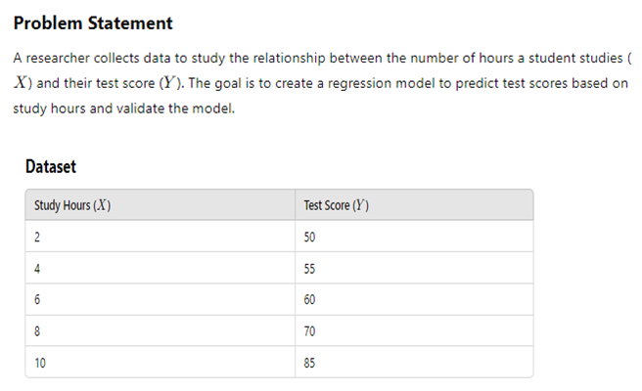

**Question: 9**

**Y=0.95X+1.5**

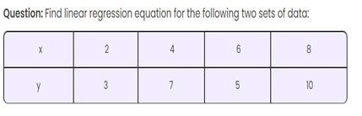

**Question: 10**

**Y=10X+70**

Sales data for five weeks is given below.

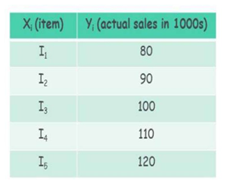

**Multilinear Regression**

**Question: 11**

**Y=**

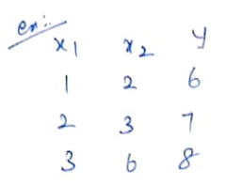

**Question: 12**

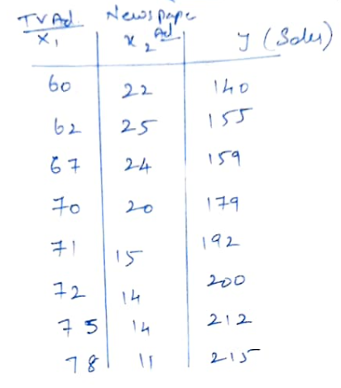

**Logistic Regression**

Formulate Confusion matrix and calculate the following ,

1. Accuracy (ii) Precision (iii) Recall (iv) F1 score (v) Log-loss
2. Assume the following values for the constants

B0=-6, B1= 0.05 B2=0.04 B3=0.03

**Question: 13**

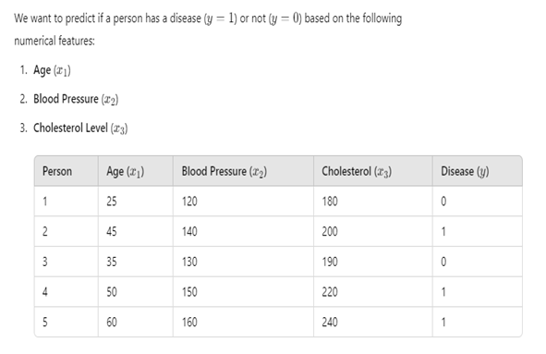

**Question: 14**

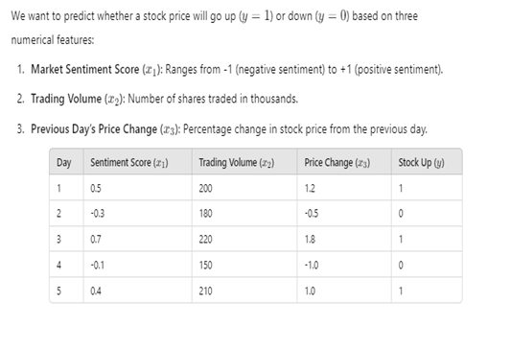

**Question : 15**

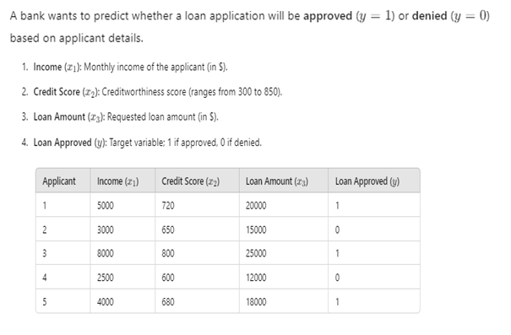

**NAIVE BAYES CLASSIFIER**

**Question 16:**

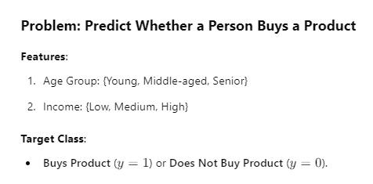

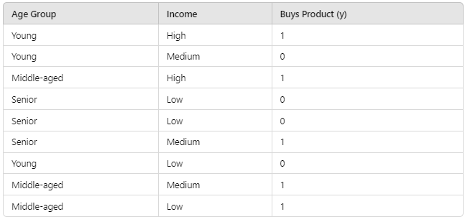

Predict the class label for the input feature X={Age=young & Income=Medium}

********output

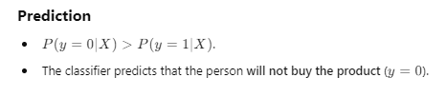

**Question:17**

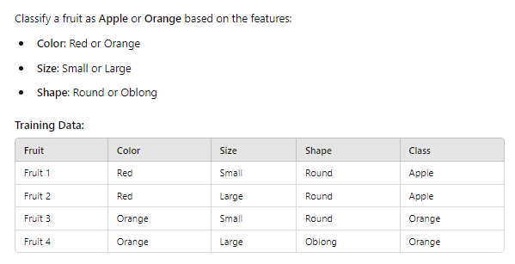

**Predict the type of fruit for the input feature { Red, Large, Round}**

**\*\*\*\*\*output**

**Question: 18**

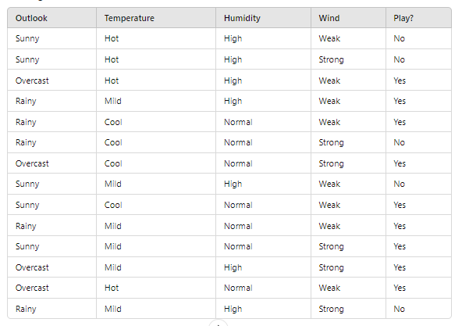

**Predict the class label for the input feature {Sunny, Mild, High, Strong}**

**Artificial Neural Network (ANN)**

**Question: 19**

**Consider a single perceptron with Sign activation function. The perceptron is represented by weight vector [ 0.4 -0.3 0.1]t and bias =0, if the input vector to the perceptron is X=‘0,2 0.6 0.5] then the output is ??**

**\*\*\*\*\*output**

**Y=-1**

**Question: 20**

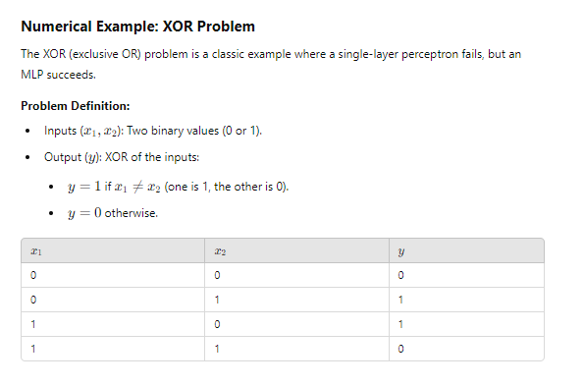

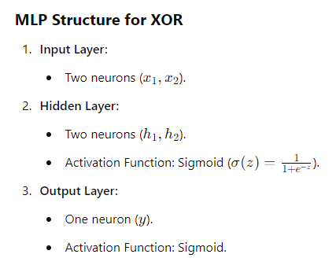

**\*\*\*\*\*\*\*\*output**

**Y=1**